PENETRATION TESTING REPORT - DAY 8
Input Validation Vulnerabilities Assessment on DVWA

1. DOCUMENT INFORMATION

Project Title : Day 8 - Input Validation Testing (XSS & SQLi)
Target Application : Damn Vulnerable Web Application (DVWA) v1.0.7
Target System : Metasploitable 2
Target IP Address : 192.168.56.102
Attacker System : Kali Linux 2023.4
Attacker IP : 192.168.56.101
Date of Testing : 20 September 2026
Tested By : Urooj Atif
Security Level : Low

2. EXECUTIVE SUMMARY

The objective of Day 8 was to identify and exploit Input Validation
flaws in DVWA. Two critical vulnerabilities were found and successfully
exploited:

1. Reflected Cross-Site Scripting (XSS) - High Severity
2. SQL Injection (SQLi) - Critical Severity

Both vulnerabilities exist because the application does not validate or
sanitize user-supplied input. All exploits were performed in a controlled
lab environment and documented with screenshots as evidence.

3. LAB SETUP & METHODOLOGY

Phase 1: Network Verification
- Verified attacker IP using command: ifconfig
- Verified connectivity to target using command: ping 192.168.56.102
- Accessed DVWA via URL: http://192.168.56.102/dvwa/
- Login Credentials Used: admin / password
- Set DVWA Security Level to: Low

[- Figure 1: Kali Linux ifconfig showing Attacker IP 192.168.56.101] 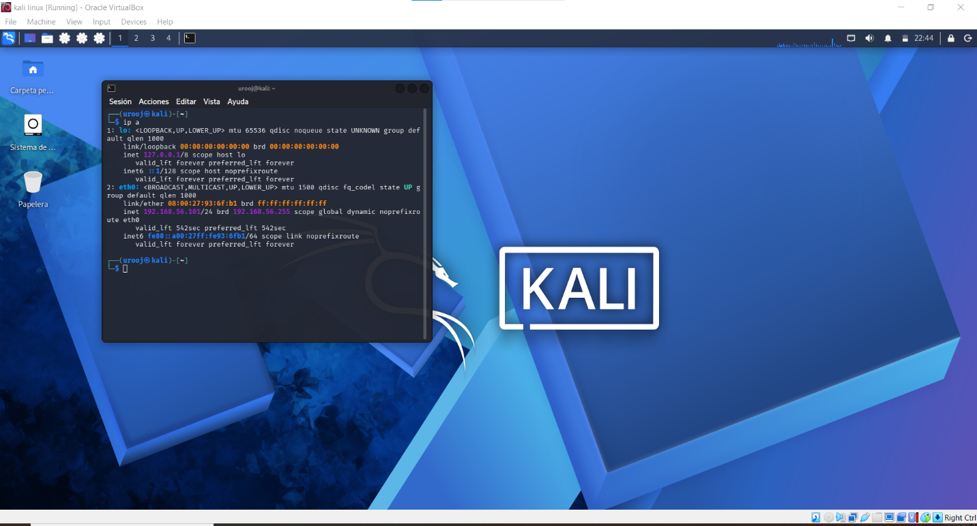

- Figure 2: Ping result to 192.168.56.102 showing successful reply] 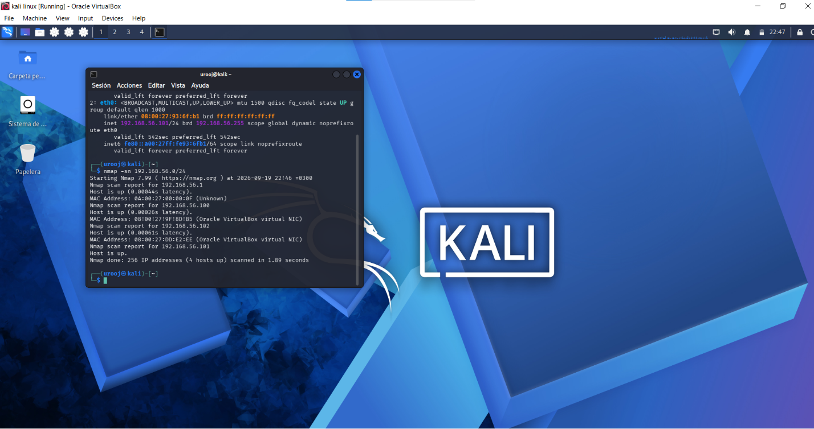

- Figure 3: DVWA Login Page and DVWA Security set to Low] 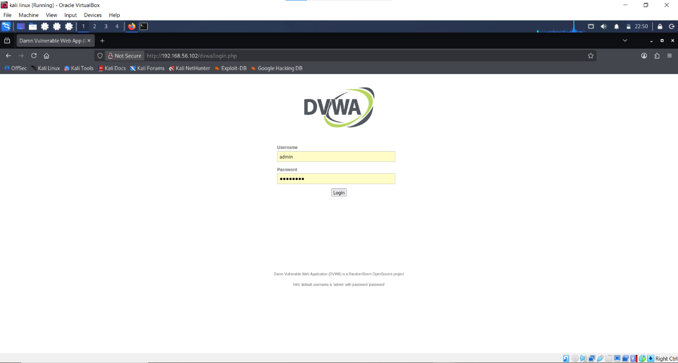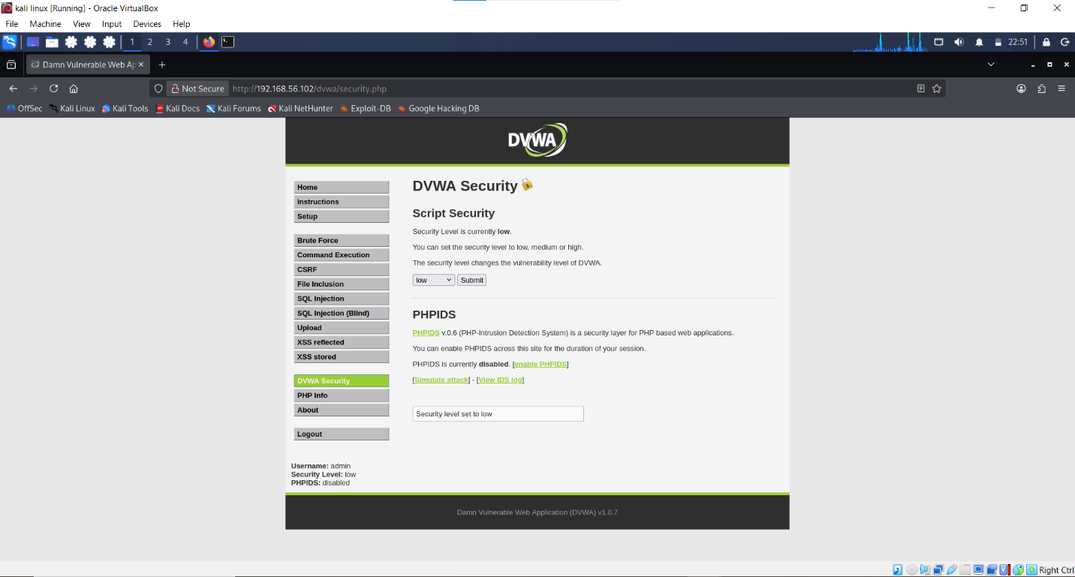

Phase 2: Vulnerability Identification
- Manual testing of input fields
- Used basic payloads for XSS and SQLi

4. VULNERABILITY FINDINGS

FINDING #1: REFLECTED CROSS-SITE SCRIPTING (XSS)

Severity : HIGH
CVSS : 7.1
Vulnerable URL: http://192.168.56.102/dvwa/vulnerabilities/xss_r/
Parameter : name

Description:
Reflected XSS occurs when an application takes user-supplied data and
immediately includes it in the HTML response without sanitization.

Steps to Reproduce:
1. Go to DVWA -> XSS (Reflected)
2. In the input box "What's your name?" enter the following payload:
<script>alert('Day8')</script>
3. Click on Submit button.
4. Observe the result.

Payload Used:
<script>alert('Day8')</script>

Evidence / Proof of Concept (PoC):
The application executed the JavaScript payload and showed a pop-up
alert box with text "Day8". This confirms Reflected XSS.

- Figure 4: XSS Reflected - Payload Entered in Input Field] 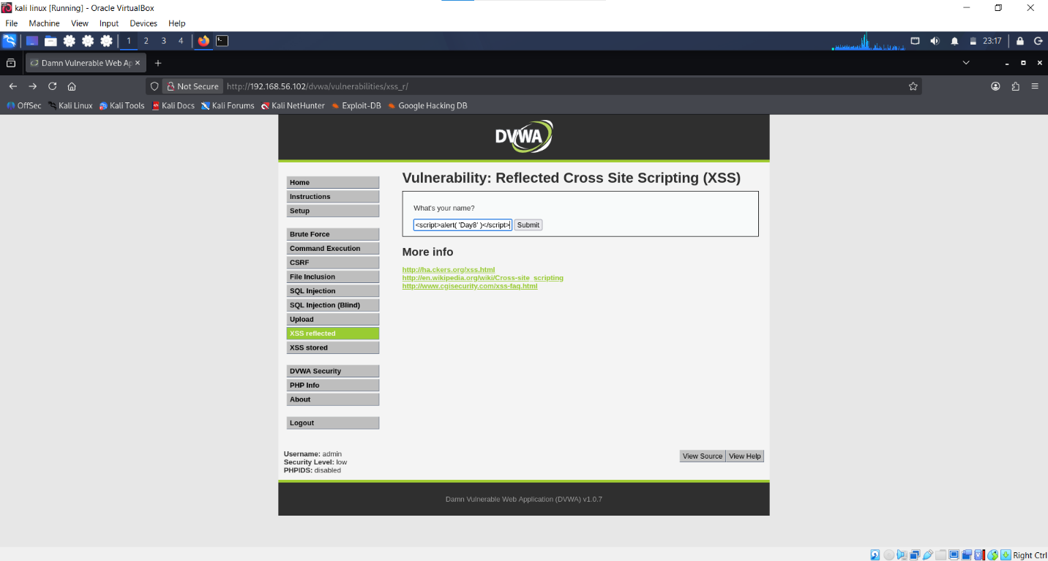

[ - Figure 5: XSS Reflected - Alert Pop-up showing 'Day8' from 192.168.56.102 - MAIN EVIDENCE] 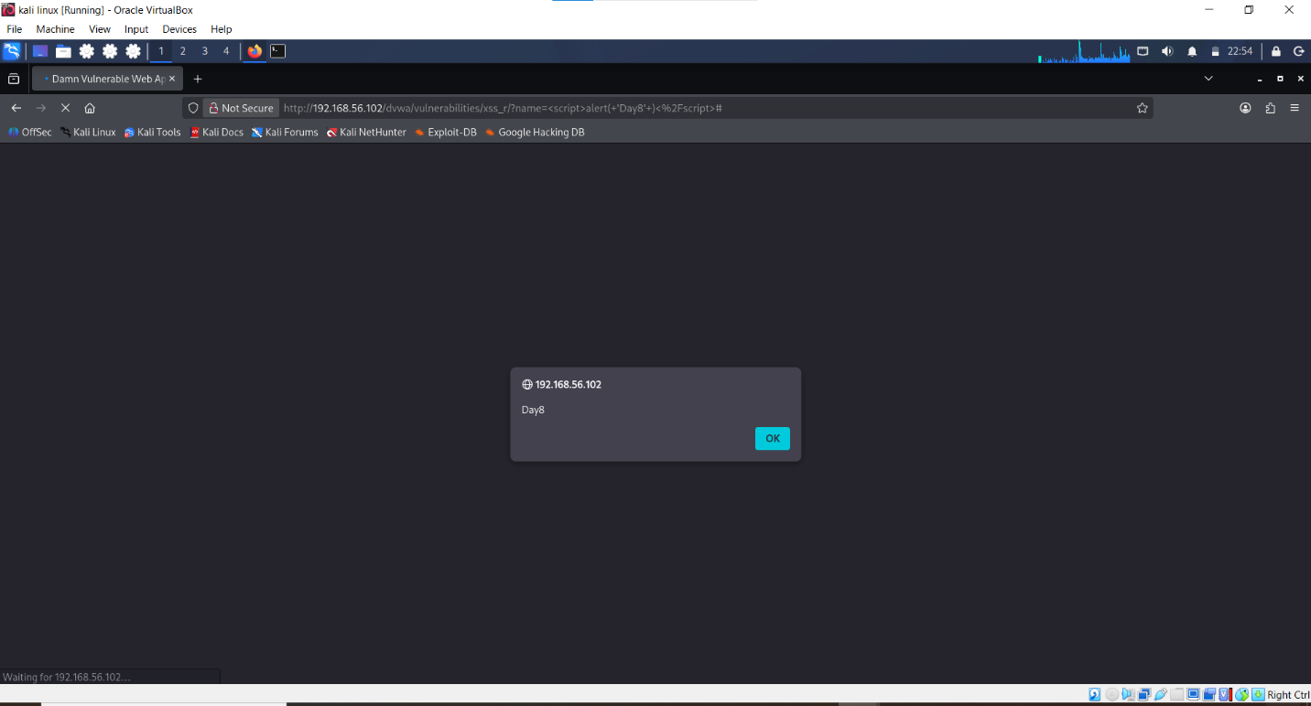

Impact:
- Attacker can steal user cookies and hijack session
- Can perform phishing attacks
- Can deface the website or redirect users to malicious site

Mitigation / Recommendation:
1. Implement output encoding using htmlspecialchars() or htmlentities() in PHP.
2. Implement Content Security Policy (CSP) Header.
3. Validate all user inputs on server-side, not just client-side.
Example Secure Code:
echo htmlspecialchars($_GET['name'], ENT_QUOTES, 'UTF-8');

FINDING #2: SQL INJECTION (SQLi)

Severity : CRITICAL
CVSS : 9.8
Vulnerable URL: http://192.168.56.102/dvwa/vulnerabilities/sqli/
Parameter : id

Description:
SQL Injection occurs when user input is directly concatenated into SQL
query without using prepared statements.

Steps to Reproduce:
1. Go to DVWA -> SQL Injection
2. In the User ID field, enter payload: ' OR '1'='1
3. Click Submit.
4. Initially application shows SQL syntax error, confirming injection point.
5. On second attempt, it dumps all users from database.

Payloads Used:
Payload 1 (For Error Disclosure): 1' OR '1'='1
Payload 2 (For Data Extraction): ' OR '1'='1

Evidence / Proof of Concept (PoC):

A) Information Disclosure via Error Message:
Application leaked MySQL error: "You have an error in your SQL syntax..."

- Figure 6: SQL Injection - SQL Syntax Error Message - EVIDENCE] 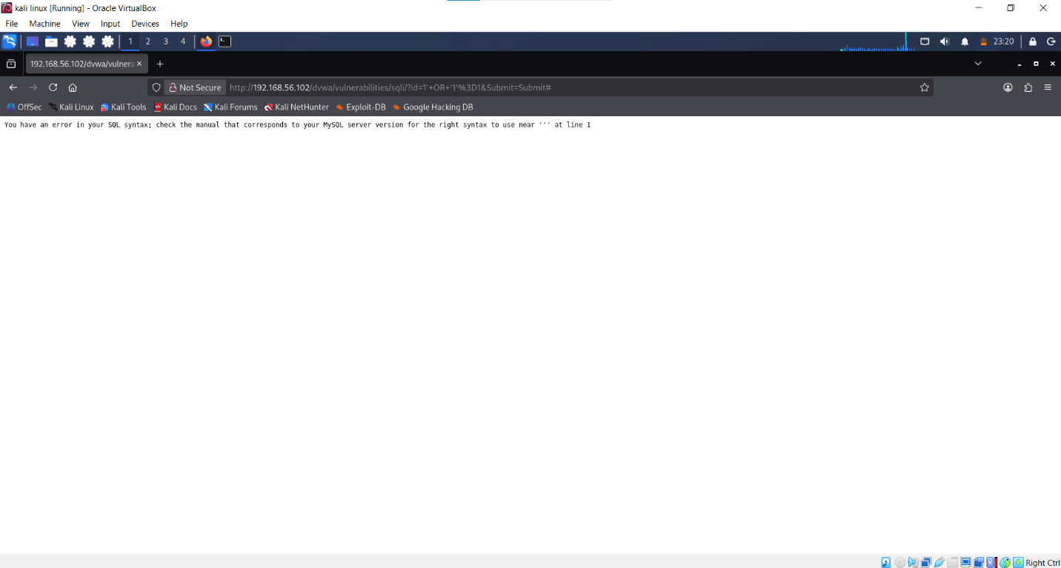

B) Complete Database Dump:
Application returned all records from users table.

- Figure 7: SQL Injection - Full User List Dump (admin, Gordon Brown, Hack Me, Pablo Picasso, Bob Smith) - MAIN EVIDENCE] 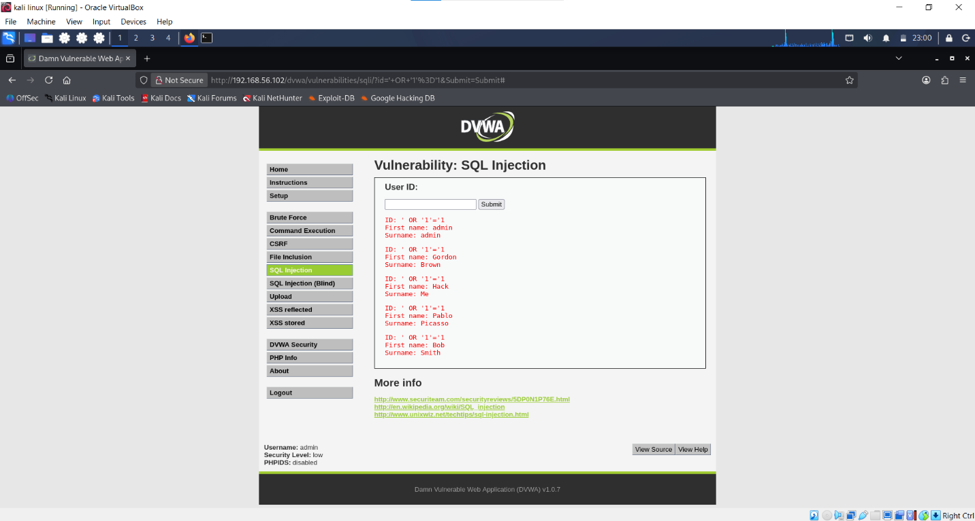

Observed Data Leaked:
ID: ' OR '1'='1
First name: admin / Surname: admin
First name: Gordon / Surname: Brown
First name: Hack / Surname: Me
First name: Pablo / Surname: Picasso
First name: Bob / Surname: Smith

Impact:
- Complete database compromise
- Authentication bypass
- Attacker can read, update, delete entire database
- Can lead to remote code execution in some cases

Mitigation / Recommendation:
1. ALWAYS use Prepared Statements (Parameterized Queries).
2. Use PDO or MySQLi with bound parameters.
3. Apply principle of least privilege for DB user.
4. Use Web Application Firewall (WAF).

Example Secure Code (PHP PDO):
$stmt = $pdo->prepare('SELECT first_name, last_name FROM users WHERE user_id = :id');
$stmt->bindParam(':id', $id, PDO::PARAM_INT);
$stmt->execute();

5. CONCLUSION

The DVWA application at Low security level is highly vulnerable to Input
Validation attacks. Both XSS and SQL Injection were successfully exploited
with simple payloads. The vulnerabilities were documented with proper
screenshots as deliverables.

The lab demonstrates why input validation is a critical security control.
Without it, an attacker can easily compromise the application and its
underlying database.

Status: DELIVERABLE COMPLETED - Vulnerability Evidence Captured.

6. APPENDIX

Tools Used: Kali Linux, Firefox Browser, DVWA on Metasploitable 2
Commands Used: ifconfig, ping
Browser Used: Mozilla Firefox ESR

--- END OF REPORT ---

